

**October 2018**

Grandview Grizzlies

68 North Park St. N3R 4J9

Brantford, ON 519 752- 2610

Website: <http://www.granderie.ca/schools/grandview>

**Principal’s Message:**

**As September draws to a close, it is hard to believe that we have been back to school for an entire month! Thank you to our staff, students, and families for helping us get the 2018-2019 school year off to a great start! It was great to meet so many of our families at our annual Meet the Teacher open house. As we look forward to the month of October, we are reminded of the many exciting events happening in our families, our community, and at our school. From sporting events to outings and visitors, our students will be busy learning from many enriching opportunities.**

**We will keep you informed of what's happening at our school through monthly**

**newsletters and our school website.** [**http://www.granderie.ca/schools/grandview**](http://www.granderie.ca/schools/grandview)

**There you will find links to school news and transportation. We also have a Twitter feed on our website if you would like to see some of the activities at the school. The address for the Twitter feed is @GrandviewGrizz**



**ATTENDANCE ROUTINES**

Student Attendance is checked twice daily. Unless you, as the parent/guardian, have

contacted the school to explain that your child will be late or absent, the school office

is required by Board Policy to verify all absentees. For your convenience, an

answering machine is attached to the school’s incoming phone line and messages can

be left during the evening and night time hours to inform the school if your child will

be absent. Please state your child’s name and the teacher’s name of his/her class when

leaving your message.

**School Council Start-up Event – October 18**

School Councils play a vital role in the education of all Grand Erie students through their work to promote and improve student achievement and school performance as well as their leadership in encouraging parent involvement at schools and learning at home. All Grand Erie Schools must have a school council. Additionally, school council elections must be held within the first 30 days of the school year.

Grand Erie’s annual School Council Start-up, sponsored by the Grand Erie Parent Involvement Committee (GEPIC), takes place Thursday, October 18 from 6-8 p.m. at Waterford District High School. All School Council Chairs, Home and School Associations Chairs or Parent Teacher Associations Chairs as well as their members are urged to attend. The School Council Start-up is an important event for all School Council Chairs as key information is provided and great ideas are shared.

For details on the event and to RSVP visit: <https://bit.ly/2MRCjqa>

**Bus Cancellation/School Closure**

In the event of bus delays, cancellations or school closures:

Visit the GEDSB website: <http://www.granderie.ca> or <http://www.stsbhn.ca/>

**Grandview School is located in ZONE 4**.

**Grandview Public School News**

# **A Few Important Notes:**

**Upcoming Dates**

October 2 PA Day

October 3 Immunization Grade 7 & 8

October 5 Picture Day

October 8 No School/Thanksgiving Holiday

October 9 Bus Evacuation

October 24 Dress Purple Day for Child Abuse Prevention Awareness

November 15 Parent Teacher Interview (Night)

November 16 PA Day (Morning Interviews)

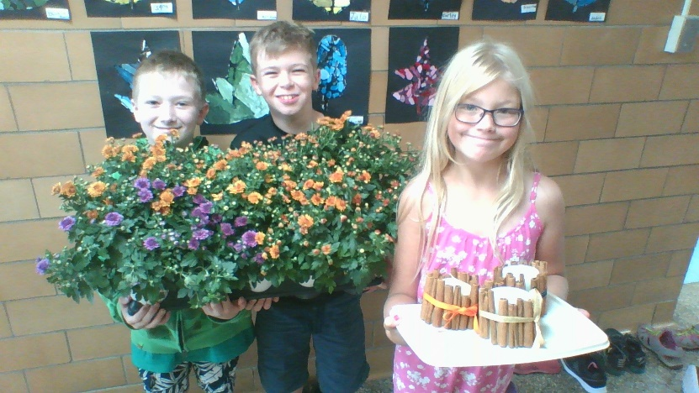 **Note from Miss Deruytter’s class:**

Miss Deruytter’s Grades 4 and 5 students will be selling Fall Centrepieces as a fundraiser for their classroom horticultural activities. The cost is $9.00 for a full centrepiece. $5 for a mum, and $4.50 for a candle. Sales began Friday, September 28th. If you are interested in purchasing any items, please send in cash with your child. Thank you.

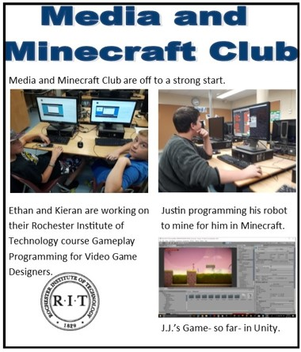

**Terry Fox Run**

On Friday, September 28th, the school participated in the Terry Fox Run. The whole school walked and ran around the block to raise money for the Terry Fox Foundation. We also had an assembly where students watched a video about Terry Fox and the history of his run. The school raised over $ 370. Great work everyone. Thanks to Ms. Marshall for all of her work in organizing the event.

**Three – Pitch Tournament**

Last Wednesday Mr. Eisenbach took the baseball team to Paris for their Tournament. The team went 1-2 with the scores being very close. Thanks to Mr. Eisenbach and Ms. Smith-Douglas for coaching the team!

**Primary Cross Country**

The primary division has been participating in Cross Country running around the back yards at the end of the day. With there being many warm days at the end of September, the students were able to get out many times and go for a run. Thanks to Mr. Murray for organizing the run!