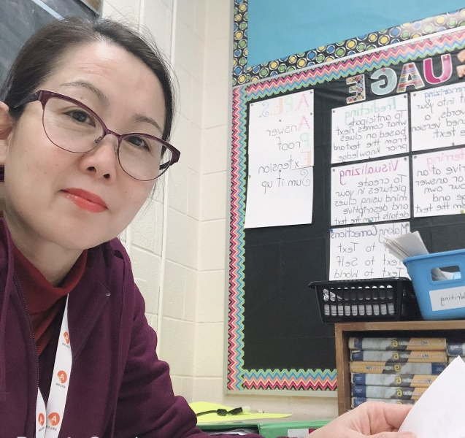
  - ELEMENTARY
  - MANDARIN LANGUAGE
  - CLASSES

Sponsored by Grand Erie Learning Alternatives
365 Rawdon Street, Brantford, Ontario, N3R 6J3
519-753-6079

In-Person, Grades JK – 3: Saturdays, 9:00-11:00 a.m.
Online, Grades 4 – 8: Sundays, 9:00 - 11:00 a.m.
- Open to students who attend a public or private elementary school in Ontario
- Led by qualified instructor Lisa Xuan
- In-person classes will start Saturday, September 16th – Grand Erie Learning Alternatives, 365 Rawdon Street, Brantford – 9:00 to 11:00 a.m.
- Online classes will start Sunday, September 17th – 9:00 to 11:00 a.m.
- To register, call 519-753-6079, Ext. #277012 or email carolyn.kelley@granderie.ca
- To register
- Call Carolyn Kelley @759-6079, Ext. #277012 to register

- #2770Carolyn.kelley@granderie.ca to register

