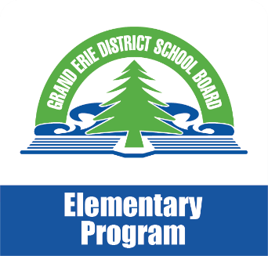
Math Moments
May 2018

The Seven Math Processes
This month’s newsletter will continue to focus on the seven key processes students engage in as they learn and use math throughout the grade. Past newsletters, focussed on problem solving, reasoning and proving, reflecting, selecting tools and computational strategies and connecting The last two processes that we will consider are representing and communication. Your child will use these processes when learning new concepts and procedures, practising skills, and solving problems. Your child will also draw on his/her knowledge and skills from the five strands and make connections with real-life situations.

Representing
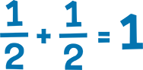
Math concepts and procedures can be represented in many different ways. Using a variety of ways to represent a concept or procedure leads to deeper understanding. Math manipulatives (physical objects students can manipulate) are particularly valuable tools to allow students to represent their thinking. They allow students to explore abstract concepts in a hands-on, concrete way. A student’s concrete representations can also give the teacher useful insight into the student’s thinking.
In your child’s math classroom, students:
- use a wide variety of learning tools to explore and represent math concepts
- use graphs, tables, words, physical and digital models, drawings, numeric and algebraic expressions and equations when solving problems

Communicating
Communicating one’s thinking and reasoning is an essential part of math. Through communication, students share and develop their understanding. Over time, students learn to use this language precisely and effectively.
In your child’s math classroom, students:
- participate in many conversations with the teacher, and with other students, in which they ask questions, share and clarify ideas, compare strategies, draw conclusions, and explain their reasoning. Everyone’s thinking is valued and considered
- communicate their math thinking orally and in writing

Taken from: Math Learning Today: produced in partnership with the Ministry of Education and Ontario District School Boards 2016

