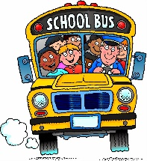
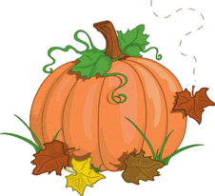
October 2023
Monday Tuesday Wednesday Thursday Friday
2 -Day 4 | 3 | 4 -Day 5 | 5-Day 1 | 6-Day 2
 | PA Day-No School for Students |  |  | Subway Day  Favourite Shirt Day
9  Thanksgiving  No  School | 10 -Day 3 | 11- Day 4  Cross Country Meet | 12-Day 5  Grade 7 Vaccine Day  Dairy Presentations -Primary Grades | 13-Day 1  Pizza Day  School Colours Day
16 Day 2 | 17 Day 3 | 18 Day 4 | 19 Day 5  Orienteering Ruthven Park | 20 Day 1  Subway Day  Plaid Shirt Day
23 Day 2 | 24 Day 3 | 25 Day 4 | 26 Day 5 | 27 Day 1  Pizza Day  School Colours Day
30 Day 2 | 31 Day 3  Halloween  Wear your costume!

