**February 2020 Newsletter**

**Inclement Weather Information:**

* Information on Student Transportation Services: http://www.stsbhn.ca
* The decision to cancel student transportation services due to inclement weather is made by 6:30 a.m. If Grand Erie schools are closed, the decision will be posted on the board’s website ([www.granderie.ca](http://www.granderie.ca/)), Twitter account ([@GEDSB](https://twitter.com/GEDSB)) and shared with local media. STSBHN will also communicate the decision to riders, post on Twitter ([@STSBHN](https://twitter.com/STSBHN)) and share on their phone line (519-751-7532, ext. 7).Information will be posted on Grand Erie’s Twitter (@GEDSB) and Facebook ([www.facebook.com/GEDSB](http://www.facebook.com/GEDSB)) accounts.
* **New to Grand Erie’s Inclement Weather Policy in 2019-20 is the option to cancel transportation services when there is extreme cold weather. In this case, student transportation services would be cancelled, however, all Grand Erie schools would remain open to students and staff.**
* **Extreme cold weather negatively impacts the operation of buses. Extreme cold weather in Grand Erie’s Inclement Weather policy is defined as -30 degrees Celsius (without wind-chill) at 5 a.m. or a high risk of frostbite (10 minutes or less) as of 5:45 a.m.**
* Closure information will also be shared with local media (i.e. radio, television).

**NEWS FROM STUDENT SERVICES**

**Course Selections 2020-2021**

The Course selection process for 2020-2021 has begun!!  Students need to complete and return their signed Course selection sheet to Homeroom teachers by Thursday, February 6th.  The Course offerings for 2020-2021 can be found on the school website under the Student Services Tab.

**Community Service Opportunities**

Looking for **Community Service** **Opportunities?**   Please visit the bulletin board in the Student Services office for postings.  Remember, you need to complete 40 hours for graduation.

**Scholarship Opportunities**

Scholarship information is posted on the board in Student Services.  Come in and check it out!!

SCS is Zone 1

**Save The Date!**

On Wednesday, Feb 19, 2020, SCS & Valley Heights Parent Council are hosting a presentation on Social Media in the gymnasium @ 6:30 pm. See the back of this newsletter for more details.

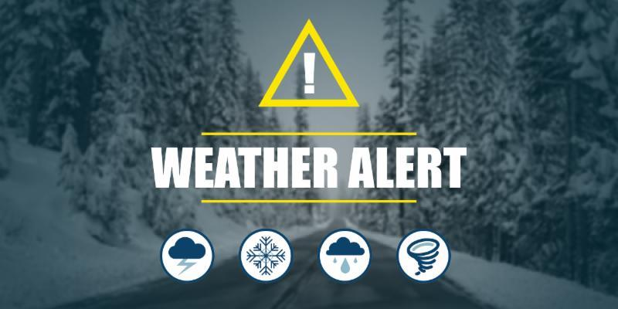

**France – March Break 2020**

*Over March Break, Madame Defreyne and Mr. Dale will be chaperoning 18 SCS students through France.  The tour begins in Paris, moves southwest to Bordeaux, dips into northern Spain, then heads eastward across the south to Carcassonne, Avignon and into the Provence region.  Students will spend their last two days in the French Riviera: Nice, Eze, and the principality of Monaco.  Ooh la la!  Note: students interested in the March 2022 SCS Eurotrip should see Mr. Dale for more information.*



**New York Trip 2020**

Mrs. Busk, Mr. Oosting and Mr. Ernst will accompany 35 students on the New York Trip to the Big Apple from April 30th to May 3rd.

We will take in all the fantastic sites that New York City has to offer: Times Square, Statue of Liberty, Brooklyn Bridge, China Town, Little Italy, Central Park, John Lennon Memorial, 911 Memorial and Museum. We will also enjoy the experience of attending a Broadway Show.

Our days are busy and packed with amazing Educational activities.



**Principal’s Message**

What a great first semester. Out with 2019 and in with 2020. In this new decade the Sabres will continue to roar louder than the rest.

The countdown to French Immersion is on. We are very excited and are currently preparing for our first class to start this September. If you would like more information on this, please contact Mrs. Ippolito at the school.

A big thank you to all the parents and future Sabres who came out to our Future Grade 9 Night. It was a wonderful evening that continues to highlight all of the great students and teachers that currently call SCS home.

Speaking of the SCS home front, we are now the proud owner of three new water bottle filling stations. That means that every water fountain at SCS is a water bottle filling station. So please continue to help the environment by bringing a refillable water bottle. At SCS we now have two new charging stations for students to lock their phones up during the day. These stations charge the phones at a fast speed and keep them safe at the same time. They are currently located in the physical education area and the library.

I am so pleased with our EQAO Scores in both the grade 9 math assessment and the OSSLT from the 2019 year. In particular, I am delighted to share that our students who study Academic English scored 94% on the OSSLT, surpassing the Provincial average of 91%.

Please feel free to use our Talking Locker button at the bottom of our webpage **www.granderie.ca/schools/scs.** It allows you to share any concerns you may have with myself and our Vice Principal.

John Della Fortuna



***DELF Challenge***

SCS will continue to offer our grade 12 Core and Immersion French students the opportunity to challenge the DELF (Diplome d’Etudes en Langue Francaise) in May.  This diploma is awarded by the French Ministry of Education to certify the competency of candidates outside France and in the French language.  These certificates are valid for life.  Good luck to all of our French students who plan to challenge the test.

**FRENCH IMMERSION STARTS SEPTEMBER 2020**

**AT SIMCOE COMPOSITE**!

SCS is very excited to be offering French Immersion starting September 2020! This is the opportunity for students to study 10 of their high school credits in French. This will create a unique dynamic in our school, enhancing French language awareness and encouraging its use among all of our French learners.

**Le français**

**Smoke-Free Ontario Act: Changes Impact All Grand Erie Schools**

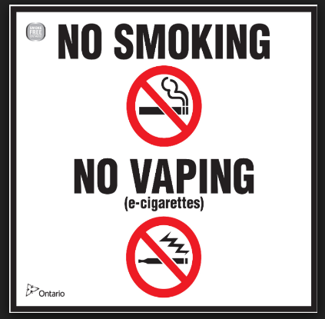Last fall, the Government of Ontario passed the Smoke-Free Ontario Act, which prohibits smoking tobacco or cannabis as well as all vaping in public areas, including schools.

The new law specifically states that a person can not smoke or vape in or around a school. This includes all indoor spaces and all outdoor areas like playgrounds and sports fields. It also prohibits smoking and vaping in public areas within 20 metres of the property line of a school or School Board facility. For reference, 20 metres equals 65 feet, or the approximate length of 1.5 school buses.

A person caught smoking or vaping in a prohibited area may be charged with an offence and subject to a fine of up to $1,000 for a first offence, if convicted.

To assist Grand Erie with this change, the local Health Unit will be providing new signage for all schools and Board facility sites. Through our Public Health Nurses, education information will be available for those looking to quit smoking or vaping. The Board will also be removing all traditional smoking and vaping areas.

Understandably, this is a significant change that will require everyone’s cooperation. We don’t want to see anyone charged. Therefore, we’re asking for your support and assistance in ensuring everyone meets the requirements of this new law.

For more information on the Smoke-Free Ontario Act, visit: <https://bit.ly/2FGV4y5>

**Vice-Principal’s Message**

Welcome to Semester Two, Sabres!

**Late Policy**

Students are expected to arrive to their classes **on time**. Period 1 begins at **8:58 am**. Teachers take the time to prepare great lessons and valuable information is missed when students arrive late. There are always mitigating circumstances, such as late buses, which will be considered. If there are legitimate reasons for regular lates, you are welcome to share them with me. Chronic lates will be handled through progressive discipline as follows:

* 8-10 lates – lunch hour detention
* 15 lates – half day detention
* 20 lates – full day detention
* 25 lates – 1 day out-of-school suspension

If you are late to class because of an appointment, please be sure to sign in at the main office, with a note or phone call from your parent/guardian. **A reminder that all absences must be verified by a parent/guardian by 11:00 am the following day, in order to avoid a lunch hour detention.**

Jennifer Ippolito

***GREAT NEWS AT SCS!!!***

<http://www.granderie.ca/schools/scs/news?bnews_cid=7703>

<http://www.granderie.ca/schools/scs/news?bnews_cid=7703>

***TWITTER:***

<https://twitter.com/SimcoeSabres>

***INSTAGRAM:***

www.instagram.com/SCS_studentCO

**Rotary Exchange Programs**

Are you interested in Youth exchange to another country? We have leadership programs, Short Term Exchange (2 month), Long Term Exchange (1 year) opportunities and we are looking for Canadian Host families to host our inbound exchange students.  You must be between 15 - 18 years old, have strong academic ability, be in good health, open-minded, tolerant and willing to try new things.

You will form lifelong international friendships, learn new ways to communicate, gain a fresh understanding of yourself and others. You will immerse yourself in another culture, potentially learn a new language and become an ambassador and educate others about Canada.

If you are interested, please send an email request to: Cheryl Peck, Youth and Exchange Officer: [cheryl@ciderkeg.com](mailto:cheryl@ciderkeg.com) or send a facebook message to: ***Rotary Club of Norfolk Sunrise***.

**SABRE SPORTS NEWS!!**

**SCS Fall CWOSSA Updates & 2nd Season Sports Review**

Both the Junior Girls’ basketball team and the Junior Boys’ volleyball team captured the NSSAA Championships in convincing wins in the Fall.  They both went on to represent District 9 at CWOSSA.  Your junior boys had some very tough competition and represented SCS very well.  The junior girls’ basketball team played outstanding and were undefeated going into the CWOSSA final.  The girls had a very thrilling basketball final against St. David’s to WIN the CWOSSA Championship 47-45 in the Sabre Dome!! The junior girls and Coach Dockx would like to thank the many parents, students and basketball fans who supported them throughout the season and were there to cheer them on in the CWOSSA final!

Hoop Hoop Hooray for our Junior Girls’ Basketball Team!!

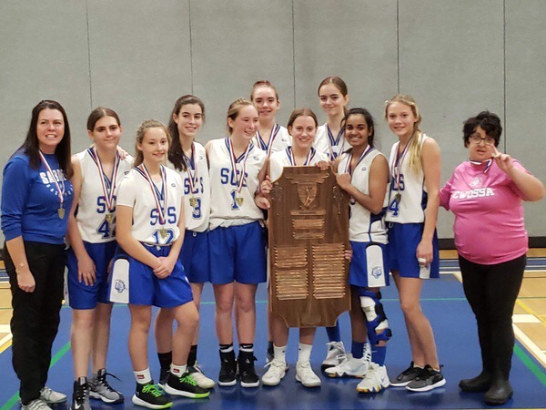

Sabre winter sports teams have continued to represent SCS in winning form! The girls’ volleyball and boys’ basketball teams are all currently in first place in league standings and all NSSAA Championships could potentially be in the SabreDome!!! The girls’ & boys’ hockey teams are practicing hard to represent SCS in the NSSAA playoffs happening in February.

For the first time in over 15 years SCS has a wrestling team! They will be attending a CWOSSA qualifying tournament in Brantford, February 12th. Good luck!

The Cheerleading team has had a great start to this school year. After coming in 2nd at the fair, they worked extremely hard to capture the NSSAA Championship at Holy Trinity in January. Now is the time to prepare for Provincials in April in Brampton and Nationals in Ottawa in May. Good luck ladies!!

Good luck to all SCS athletes!!  We are all very proud of your efforts!

Spring sport teams will be having their try-outs after March Break, students should listen to announcements for dates and times or see any phys-ed teacher for further information on spring teams.

The phsy-ed department always welcomes volunteer coaches and also has many opportunities for student volunteer hours. Please see a phys-ed teacher if you or your student are interested in volunteering.

JUNIOR FOOTBALL CAMP

Junior Football Camp for all Grade 9 and 10 students will begin Thursday, May 14th and run until Thursday, June 4th. Hope to see you there!!!

