LE BULLETIN D’ AVRIL 7/8
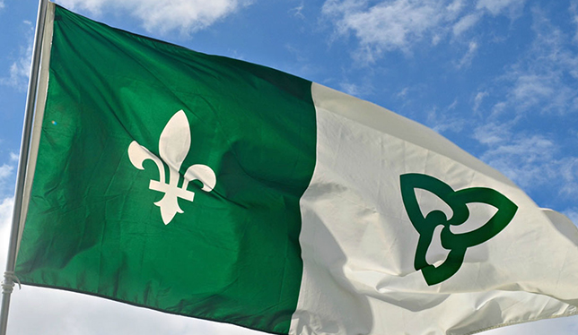
Bonjour!
C’est un nouveau mois et il y a un nouveau projet ! At the end of March, the students got a head start on their French speaking area or country project. Each student was given a page outlining the project as well as a sheet explaining the marking system.
It will be wonderful to see each student’s poster and hear them discuss their French speaking part of the world by using simple French. As listed on the handout;
- the poster should be divided into the 4 outlined sections,
- Grade 7 students will talk for 2 to 3 minutes in French and
- Grade 8 students will talk for 3 to 5 minutes in French.
The students were given time in class to commence the project. Any unfinished work is to be completed at home. Presentations begin on Monday, April 8th.
It is highly recommended that students practise their presentation beforehand in front of their family or friends to ensure that it is within the time parameters and in order to practise fluency. The presentation does not need to be memorized; however, students should try to look up from time to time from their cue cards or notes. The pupil should be pointing to his/her poster and should be using grade appropriate French so that all of the students can learn and understand the presentation.
Fun French Fact – In New Brunswick, some of the French speaking Acadian population are mixing English words in to the French language and are creating the dialect called “Chiac”.
Bonne journée,
Mme Sorensen

