PLE: Ed Tech Professional Development
Professional Learning Environment Registration
Ed Tech has created a Professional Development module for educators. Educators can access the module in the Virtual Learning Environment (VLE) Brightspace by Desire2Learn.

How to Access the VLE
Go the Virtual Learning Environment.
Click “Virtual Learning Environment” under Resources on Grand Erie homepage: http://granderie.ca
Or
http://gedsb.elearningontario.ca
If you are on the Grand Erie network, you will be passed through. If you are not on the Grand Erie network, log in with your Grand Erie email and password.

How to Access the Module
When you enter the VLE, you will land on your My Home page. Select “Self Registration (Master Courses)”.
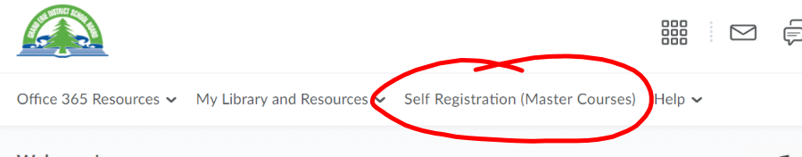

Use ctrl+f to search
Search “Ed Tech”
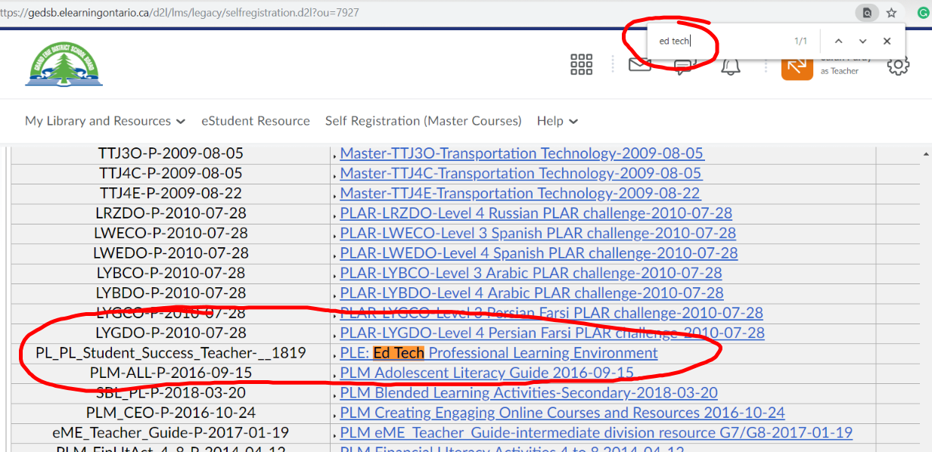

Click PLE: Ed Tech Professional Learning Environment to self-register. Follow steps to self-register.

When you finish the registration process, click the Grand Erie icon at the top left of your screen return to your My Home page.
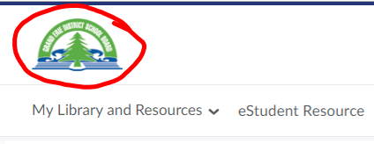

Scroll down to your My Courses widget. If you don’t see the PLE: Ed Tech Professional Learning Environment in your widget, click “View All Courses”.

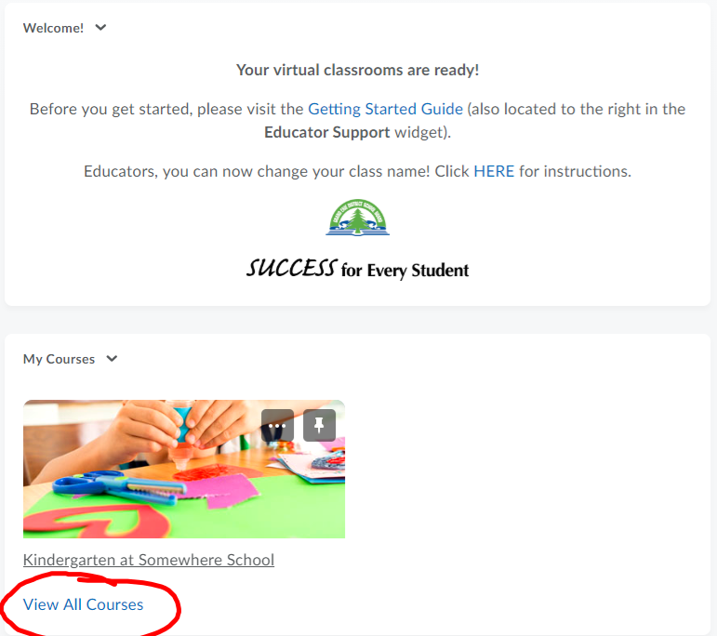

To find the PLE: Ed Tech Professional Learning Environment search “Ed Tech” and click the magnifier glass. Once you see the module, hover over the top right corner of the module and click the ellipses and select “Pin”. Once you pin, click the “x” at the top right of the screen to return to your My Home page.
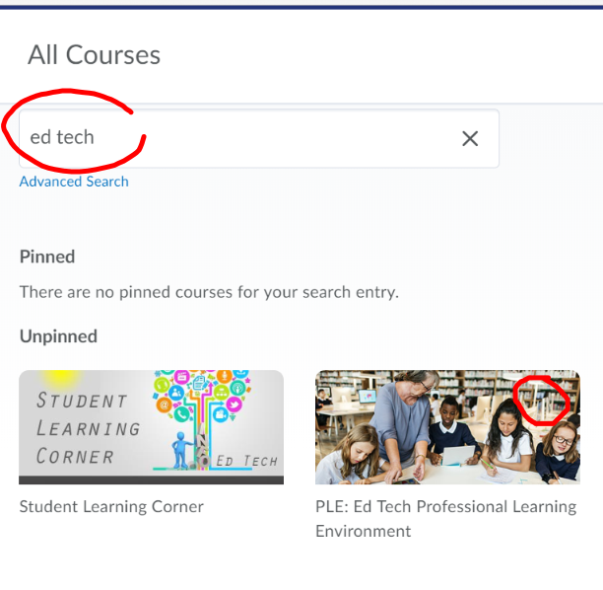
Now you will see the PLE: Ed Tech Professional Learning Environment on your My Home page. Click the learning environment to access.

If you run into any trouble accessing the VLE or registering for the PLE: Ed Tech Professional Learning Environment, please email sarah.purdy@granderie.ca

