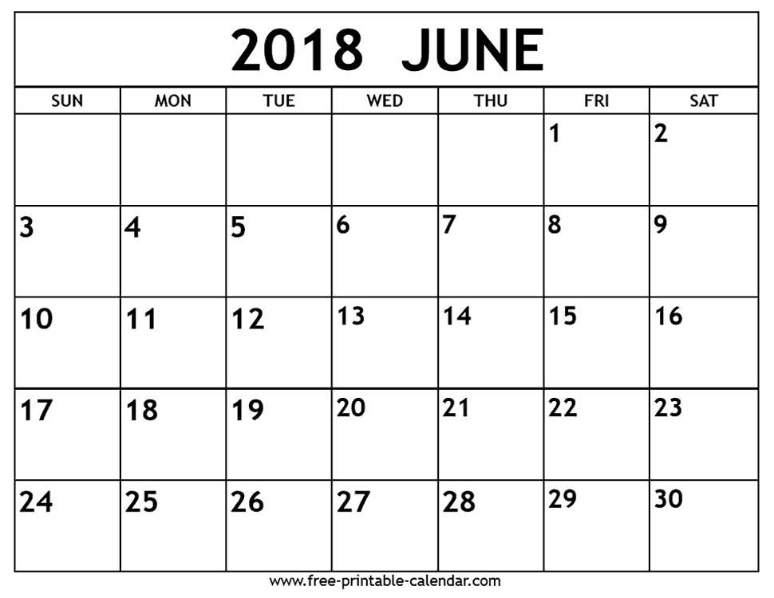

Report Cards go home

Spelling Bee

Hat Day for the Hospital. Bring in $$

Supermeet at TCES

Year End Assembly

Last day of School. Class Party

PD Day. No school for students

Trip to Rock Point

Trip To Skyzone

PD Day. No School for Students