January

Focus This Month!
- Reading: Point of View
- Writing: Story writing using Point of View and Rants
- Science: Finishing up Habitats and Human Body Systems
- Math: Geometry and Area and Perimeter

Reminders:
- Book orders Due Friday, January 19th
- Bring spare clothing for unforeseen weather
- Wear warm clothing on Chilly days
- Practice Reading while focusing on parts of a story

Important Dates:
- January 12th- Turkey Sub Lunch
- January 19th- Pizza Lunch
- January 19th- Responsibility Assembly
- January 22nd- PD Day
- January 26th- Spaghetti Lunch

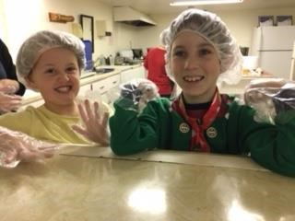
****Now here is my secret. It is very simple. It is only with one’s heart that one can see clearly. What is essential is invisible to the eye. – Antoine de Saint-Exupery, The Little Prince****

