DECEMBER 2017
Sunday | Monday | Tuesday | Wednesday | Thursday | Friday | Saturday
HOT LUNCH MUST BE ORDERED A MONTH IN ADVANCE! | Milk is delivered each day to the class. Pre-ordering online for the month is mandatory. | 28  CASHLESS ONLINE ORDERING IS MANDATORY | 29  Book Fair | 30  Book Fair | 1 Panzerotti  Hot Lunch & Milk $ Due for January  Int. Boys Volleyball @ SCS  Book Fair  Wear Your House Colours! | 2 Book Fair  Santa Sale  9am-1pm  Come join us at the school!
3 | 4 Crackers & cucumbers  LPG Mtg @ 6pm | 5 Pizza  Gr ¾, 4, 5, 6 to Strand in Simcoe | 6 Bagels & carrots  Int. Girls Volleyball @ Lakewood | 7 Snack left overs | 8 Dominos Chicken  Holiday Head Gear Day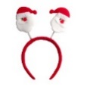 | 9  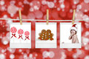
10 | 11 Clementines & cereal bars | 12 Pizza  SCS Concert Band @ 12 | 13 Pita, hummus & cucumbers  JK, SK, & GR 2  Dental Check @ 9am | 14 Snack left overs  Jr Volleyball Tournament @ Lakewood | 15 Pita Pit  Christmas Colours Spirit Day | 16
17  No hot lunch this week | 18 Apples, cheese & crackers | 19  Turkey Dinner for all students /Formal Wear Day  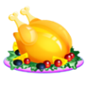 | 20 Snack left overs  Food Bank Donations for  Christmas Concert  @ 1:30 pm  & 5:30 pm | 21 | 22 | 23  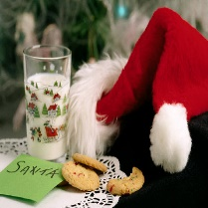
24 | 25  Happy  Holidays! | 26 | 27 | 28 | 29  See you  Jan 8th! | 30/ 31  Happy New Year!
CASHLESS ONLINE: www.schoolcashonline.com to register

