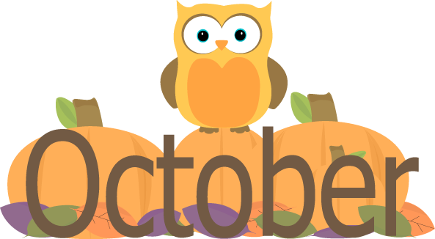
Mrs. Packham Grade 1
Dear Parents,
Wow I can’t believe it is October already. September was filled with learning classroom rules and routines. There are a lot of things happening in October so please have a look at our classroom calendar and the school calendar I have attached both to the Class Dojo). For hot lunches you pay and order everything online.
General Information
Newsletters…. Each month I will be posting a newsletter and caldendar to the Thompson Creek Elementary School’s website and on the Class Dojo, highlighting events from the past month and what is coming up in the current month.
Communication Books…These are getting hard to follow and find notes that are sent in. I am going to ask from now on if you are sending a note and you do not want to send it through Class Dojo please date your note and write it in the back of the book. I will also write any notes to you in the back of the book and date them. I will also use the Class Dojo to communicate messages to you.
Show and Tell… A way for your child to share with his/her classmates what they love and know will be through show and tell. For those students that didn’t have a chance to share in September you are up first in October. Sharing for the month of October is “My Family”. Please share about your family. If you aren’t comfortable sending pictures with your child you can send them to me through class dojo and I can put them up on the white board during their share time.
Class Dojo….I am happy to report that we have 95% of our class connected through the Class Dojo. I will continue to send out messages about upcoming events and I will continue to post pictures of things happening in our classroom. If you would like to see something posted that isn’t being posted please let me know.
Physical Education/DPA…. We will have either Physical Education or DPA (Daily Physical Activity) everyday. Please make sure that your son/daughter has running shoes to participate. A change of clothes is not necessary. They will have Mr. Taylor for Physical Education.
Library…. We are scheduled to go to the library on Day 1 with Mr. Overend and Day 3 with myself. Please return books as you are done with them and we will get them switched for a new one as soon as we can.

Focus:
Reading – We will be reviewing our vowels this month. We will focus on one each week with our spelling.
Writing – We are going to work on using capitals, periods and finger spaces in our writing.
Math – We are going to finish up our unit on counting and recognizing numbers and we are going to start patterning.
Science – We will be continuing with the Needs and Characteristics of Living Things

Notes from the Office
Due to allergies we will not be handing out any snacks/treats to the entire class so please do not send anything from home to share.
We are attempting to decrease our consumption of paper therefore newsletters and calendars will be posted online.
Please register for online payments, this is where you will be able to pay for anything school related.
Please feel free to contact me at the school or through the Class Dojo with any questions that you have.
Let’s have a great year!
Mrs. A. Packham
905-774-5460

